UONL Attendance Guide

Contents
Importance of Attendance 3
How to Access your Attendance Record 4
How Can I Contact the Attendance Department? 8
Attendance Procedure 10
FAQs 14
In class FAQs 14
Online FAQs 15
Other FAQs 16

Importance of Attendance

The University wants you to do the best you can in your studies. There is a wealth of research that has proven that students who achieve well are those that attend well. You owe it to yourself to benefit as much as you can from your investment with us. It will be difficult for us to confirm you as an active student to the SLC if your attendance is not recorded correctly.

You are expected to join your university classes and zoom webinars on time, so please consider any transportation or internet issues. If you join your class more than 30 minutes after the session begins, you will be recorded as absent. You may be required to meet with your Personal Tutor or Course Leader to discuss your attendance or punctuality.

How to Access your Attendance Record

Step 1: Select VLE from the UONL Website: https://london.northampton.ac.uk/

Step 2: Enter your VLE login details (your default password will be your date of birth in a six-digit format, if you have not changed it)

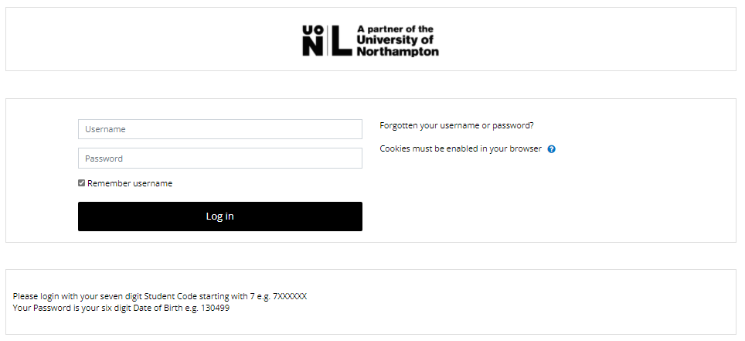

Step 3: Find ‘Service’ on the right-hand side of the screen.


Step 4: Select ‘Attendance’ under ‘Services’ on the right-hand side of the homepage




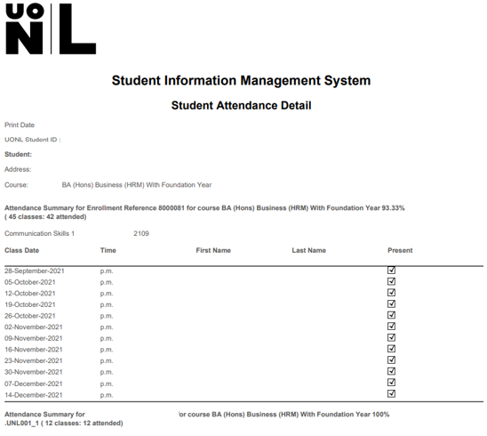
1
3
2
Step 5: Check your Attendance Record

4

- States your attendance summary over the course of your degree and your attendance percentage.
- States your module title and the term that the summary below relates to. For this student, they are taking Business and HRM in September 2024, so the term code is 24 (for the year) and 09 (for the starting month) so 2109



- States the date that the class was held, the session time, your name, and whether you were marked present. A tick means you have been marked present and no tick means you have been marked absent.
- States the attendance summary and attendance percentage for that particular module

- States the date that the class was held, the session time, your name, and whether you were marked present. A tick means you have been marked present and no tick means you have been marked absent.

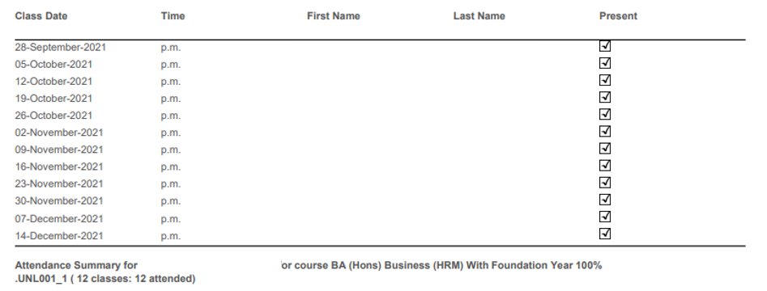

- States the attendance summary and attendance percentage for that particular module:

How Can I Contact the Attendance Department?
To contact the Attendance Department, you will need to make an online enquiry via the VLE. Please follow the steps below to do this.

Step 1: Log into the VLE using the following credentials: Username 7xxxxx / Password DOB in a 6-digit format (DDMMYY). You can access the VLE via https://london.northampton.ac.uk/
Step 2: Once you have logged in, click on the tab ‘My Forms’.



Step 3: Select the ‘Attendance Enquiry Form’.
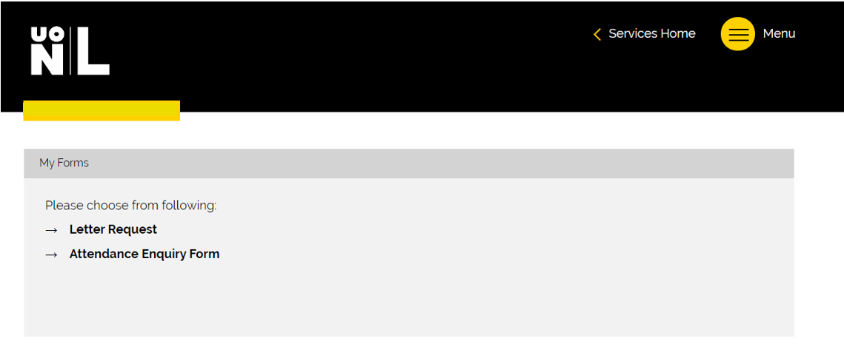

Step 4: According to your enquiry; complete the required fields including the date you were marked absent and the session (AM or PM) and the Module title. Please add any additional information that will help the attendance team with your enquiry. Once you have done this, tick confirm and submit.

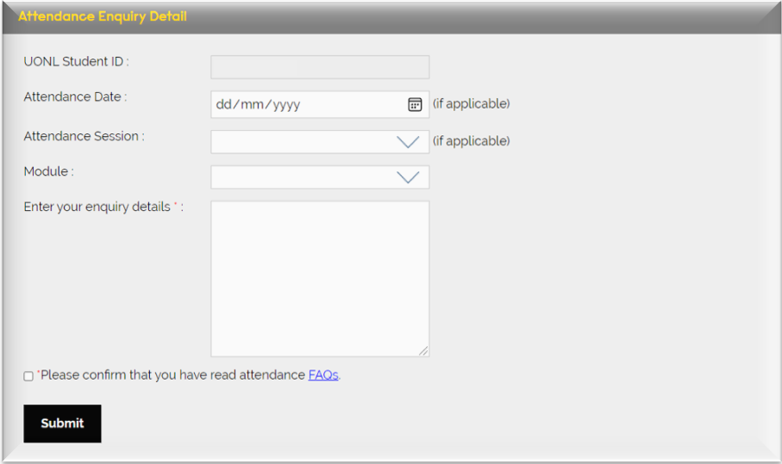

All attendance enquiries will be responded to within 5 - 10 working days and you will be contacted via your student email.

Attendance Procedure

In Class Attendance
Step 1: Select VLE from the UONL Website: https://london.northampton.ac.uk/

Step 2: Enter your VLE login details (your default password will be your date of birth in a six-digit format, if you have not changed it)

Step 3: On the right-hand side of your screen, select ‘Timetable’ and check which module you need to attend on the day.



Step 4: Click on the module page


Step 5: Click on ‘In Class attendance’ if you are attending physically in the building.
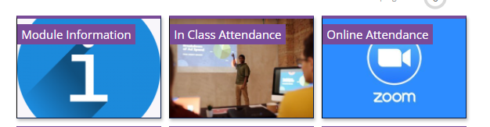

You MUST connect to UONL WI-FI to use this service:
East India: UoNL.Wifi
Password: UONL@2021!

Please note your attendance will be updated ONLY If you click this link on the day of your lesson between the times shown below whilst physically attending the lesson in the classroom:
AM Sessions: between 09:45 – 10:30.
PM Sessions: between 13:45 – 14:30.
(If you join your class after 10:30/14:30, your attendance will not be recorded, and you will be marked as absent.)

Step 6: Click on the link highlighted in blue
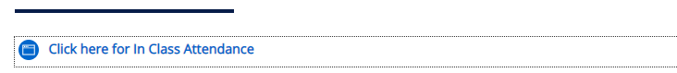

The below message will appear if you have followed the correct procedure and your attendance will be recorded.

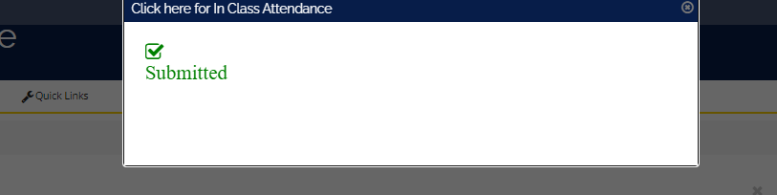

Online Attendance

Please access your Module page by following the same procedure as shown above for the In Class attendance, then:

Step 1: Click on Online Attendance if you are attending your class on Zoom.

Step 2: Click on the link highlighted in blue
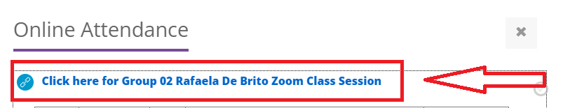

Please note, your attendance will be recorded ONLY If you click on the link on your VLE – if you input the meeting ID on the Zoom App or use a link sent by a friend, your attendance will not be recorded.
Please click on the link between the following timeframes:
AM Sessions: between 09:45 – 10:30.
PM Sessions: between 13:45 – 14:30.
If you join your class before the above hours or after 10:30/14:30, your attendance will not be recorded, and you will be marked as absent.

FAQs

In class FAQs
I am not able to connect to the UoNL.Wifi
Make sure you are using the correct password - UONL@2021!
I am not able to use my device.
Please access one of the computers available on site – please ask at the iCentre where you can find the nearest computers around the building.
Can someone else record my attendance for me?
No. This is a form of gross misconduct. Students found accessing someone else’s VLE to record their attendance on the first occasion may become ineligible for the Travel Bursary. Those who persistently do it for others may risk expulsion from the university. Classroom checks are conducted regularly by senior management.
My Attendance Record is incorrect
Please make sure to follow the below timeframes:
AM Sessions: between 09:45 – 10:30.
PM Sessions: between 13:45 – 14:30.
If you join your class before the above hours or after 10:30/14:30, your attendance will not be recorded, and you will be marked as absent.

Online FAQs
Why have I been marked absent for my online class?
The way the system records your attendance is by logging every time you click on the integrated Zoom link on your VLE throughout the day.
Reasons you may be marked absent:
• Arriving to your Zoom webinar late or early
• Manually entering the meeting ID into Zoom
• Clicking on the wrong webinar link on VLE
• Using a webinar link sent by a colleague or academic

I joined my class at 7am, then again at 10am, and I was still marked absent?
Please note that the attendance system registers the first click. Therefore, if you try to access your classes too early, your attendance will not be recorded.

Other FAQs
Can an academic amend my attendance?
No, academic members of staff cannot amend your attendance.
My lecturer takes a paper register; can I use this as evidence of my attendance?
If your lecturer takes a physical paper register, this is for their reference only and not evidence of your attendance. You must follow the attendance procedure accordingly in order to record your attendance.
I have attended a class trip organised by the university, but I am marked absent, what can I do?
In the event of a class trip the academic staff liaise with the timetabling office to ensure attendance is not affected, however if you believe that you have been marked absent for a trip that you attended it is vital that you get in touch with the Attendance Department to ensure there are no errors.
My classes have had presentations this week and my lecturer told me not to attend – will this affect my attendance record?
If your classes have presentations, then this is removed from your timetable as a formal class is not scheduled. Therefore, this should not affect your attendance record. However, if you believe your presentation classes are incorrectly appearing on your attendance record then please get in contact with the Attendance Department.
I am going to be absent for longer than 2 weeks what do I do?
For an absence of longer than two weeks we suggest that the students get in contact with the Director of Studies department to discuss a potential intermission depending upon their personal circumstances and the point that they are in their studies.
I have provided evidence to support my reason for my absence, will my attendance be amended?
If you are unable to attend a class or several classes at UONL for any reason, then you are marked absent as you were not physically present in the building. However, when that absence is beyond your control or relates to a personal circumstance we encourage you to provide a reason and evidence for your absence. This is then attached to your student record.
When can my attendance be amended?
Your attendance will only be amended for technological errors.
Can I attend a class that is not scheduled on my timetable, and will it affect my attendance?

You should only be attending classes on your scheduled timetable, which you should regularly check each semester as it is liable to change.
How do I know if my attendance has been recorded?
It is your responsibility to ensure that your attendance is recording accurately. You should check your attendance frequently on VLE.
My attendance record is incorrect, what do I do?
If you think that your attendance record is inaccurate, please send an attendance enquiry (VLE) to Attendance Department as shown in the first pages of this guide.

For further queries about your attendance record, please contact icentre@london.northampton.ac.uk or you can contact us through our zoom live chat service.

